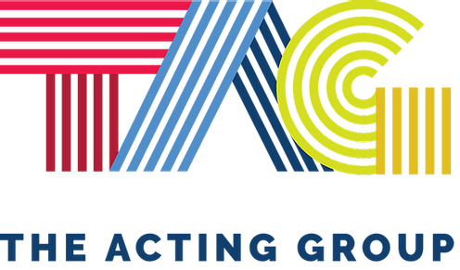
Emily Baker
Ph :512-375-2860/Direct: 870-715-5236
jorge@tagtalentagency.com/tony@tagtalentagency.com

Film/Music Video:
Black Joe Lewis
“Girls on Bikes” Biker Girl Directors, Sean Daigle &Connor Beitel
Destroyer The Gaurdian Director, John Byron Hanby
Mr. Bell Upstairs Gabi Director, Aden Wexberg
Dig Katie Director, Stephen Belyeu
Ruths Locket Young Ruth Director, Gene Burns
Steps Designer Director, Yuta Yamaguchi
Picnic Whitney Director, Alexandra Thomas
*Commercials Available Upon Request

Theater:
Fort Hood Project Army Captain/Wife Human Domain Solutions
Cuckoo’s Nest Nurse Ratched The Lyric Theater, AR
Baby Angels Rachael The Lyric Theater, AR
Jungle Book Queen Cobra The Lyric Theater, AR

Training:
Laurel Vouvray Master Scene Class In the Moment Acting Studio, Austin, TX
Ed Johnston Actors Intensive In the Moment Acting Studio, Austin, TX
Seth Yanklewitz Scene Workop In the Moment Acting Studio, Austin, TX
Ck McFarland Advanced Acting Class Alleywood Studios, Austin, TX
Mona Lee Film Acting Austin, TX
Donise Hardy Commercial Workshop Austin, TX
Brock Allen Casting Commercial Workshop Austin, TX
Sylvia GAllo Voice Coach Austin, TX
Suzi Stern Vocal Coach Austin, TX
Mike MaHoney Acting on Stage Harrison, AR
Mark Tillman Acting Intensive(CSA) Little Rock, AR

Skills:
Sing: Strong Alto, Basketball: Shooting Guard , Crossfit: Olympic Lifting, Softball, Swimming, Dance: Jazz, contemporary, and Hip Hop

